

**JOMO KENYATTA UNIVERSITY OF AGRICULTURE AND TECHNOLOGY**

**SCHOOL: COLLEE OF ENGINEERING AND TECHNOLOGY**

**DEPARTMENT: ELECTRICAL AND ELECTRONICS ENGINEERING**

**UNIT: COMPUTER PROGRAMMING II**

**UNIT CODE: SMA 2276**

**TITLE: CAT 2**

**LECTURER: MR. BETT**

**SEMESTER: 3.2**

**YEAR: 2023**

**GROUP MEMBERS**

|  |  |
| --- | --- |
| **STUDENT NAME** | **STUDENT REG. NO** |
| **GRACE KARINGA** | **ENE211-0012/2020** |
| **CYNTHIA CHEPKURUI** | **ENE211-0014/2020** |
| **CELINE KARIUKI** | **ENE211-0032/2020** |
| **NICOLE BEATY** | **ENE211-0038/2020** |
| **LENOX NZIA** | **ENE211-0050/2020** |

**No.1**

**INPUT**

#include <iostream>

#include <string>

using namespace std;

// Book class to store book details

class Book {

public:

string author;

float price;

string title;

int book_number;

int num_copies;

};

// Library class to maintain inventory

class Library {

protected:

Book books[100];

int num_books;

public:

// Constructor to initialize library with zero books

Library() {

num_books = 0;

}

// Add a book to the inventory

void add_book() {

Book new_book;

cout << "Enter author: ";

cin >> new_book.author;

cout << "Enter price: ";

cin >> new_book.price;

cout << "Enter title: ";

cin >> new_book.title;

cout << "Enter book number: ";

cin >> new_book.book_number;

cout << "Enter number of copies: ";

cin >> new_book.num_copies;

books[num_books] = new_book;

num_books++;

}

// Edit a book in the inventory

void edit_book() {

int book_num;

cout << "Enter book number to edit: ";

cin >> book_num;

for (int i = 0; i < num_books; i++) {

if (books[i].book_number == book_num) {

cout << "Enter new author: ";

cin >> books[i].author;

cout << "Enter new price: ";

cin >> books[i].price;

cout << "Enter new title: ";

cin >> books[i].title;

cout << "Enter new number of copies: ";

cin >> books[i].num_copies;

cout << "Book details updated successfully." << endl;

return;

}

}

cout << "Book not found." << endl;

}

void display_books() {

if (num_books == 0) {

cout << "No books in inventory." << endl;

} else {

cout << "Book List:" << endl;

for (int i = 0; i < num_books; i++) {

cout << "Author: " << books[i].author << endl;

cout << "Price: " << books[i].price << endl;

cout << "Title: " << books[i].title << endl;

cout << "Book Number: " << books[i].book_number << endl;

cout << "Number of Copies: " << books[i].num_copies << endl;

cout << endl;

}

}

}

};

class ChiefLibrarian : public Library {

public:

// Display all books in the inventory

void display_books() {

if (num_books == 0) {

cout << "No books in inventory." << endl;

} else {

cout << "Book List:" << endl;

for (int i = 0; i < num_books; i++) {

cout << "Author: " << books[i].author << endl;

cout << "Price: " << books[i].price << endl;

cout << "Title: " << books[i].title << endl;

cout << "Book Number: " << books[i].book_number << endl;

cout << "Number of Copies: " << books[i].num_copies << endl;

cout << endl;

}

}

}

};

// Main function

int main() {

Library library;

ChiefLibrarian chiefLibrarian;

int choice, role;

cout << "What's your role: "<< endl;

cout << "1. Librarian" << endl;

cout << "2. ChiefLibrarian" << endl;

cin >> role;

while (true) {

cout << "1. Add Book" << endl;

cout << "2. Edit Book" << endl;

cout << "3. Display Books" << endl;

cout << "4. Quit" << endl;

cout << "Enter your choice: ";

cin >> choice;

if (role == 1) {

switch (choice) {

case 1: cout << "Restricted choice. You do not have access to this method." <<

endl;

break;

case 2: cout << "Restricted choice. You do not have access to this method." <<

endl;

break;

break;

case 3:

library.display_books();

case 4:

return 0;

default:

cout << "Invalid choice. Please try again." << endl;

}

} else {

switch (choice) {

case 1:

chiefLibrarian.add_book();

break;

case 2:

chiefLibrarian.edit_book();

break;

case 3:

chiefLibrarian.display_books();

break;

case 4:

return 0;

default:

cout << "Invalid choice. Please try again." << endl;

}}

}

}

**OUTPUT**

i)When the librarian is identified as the user

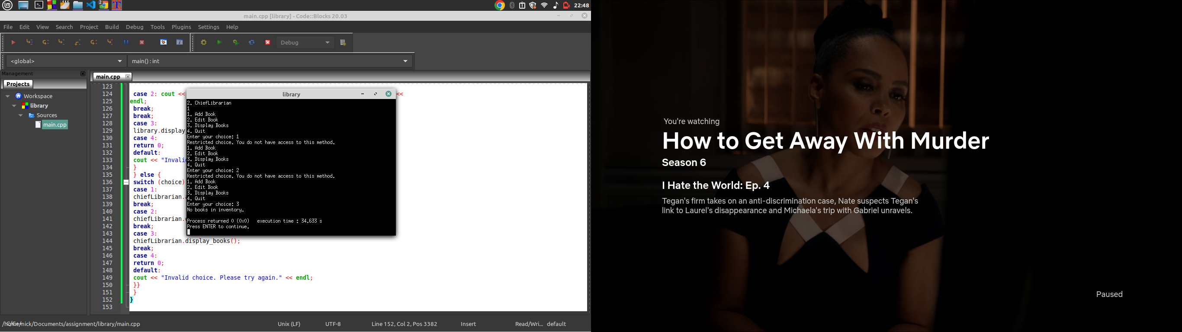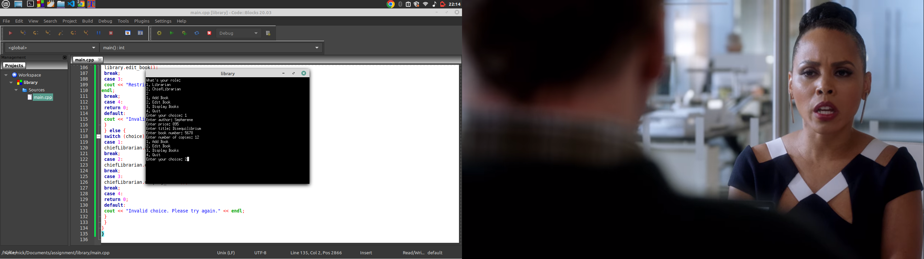

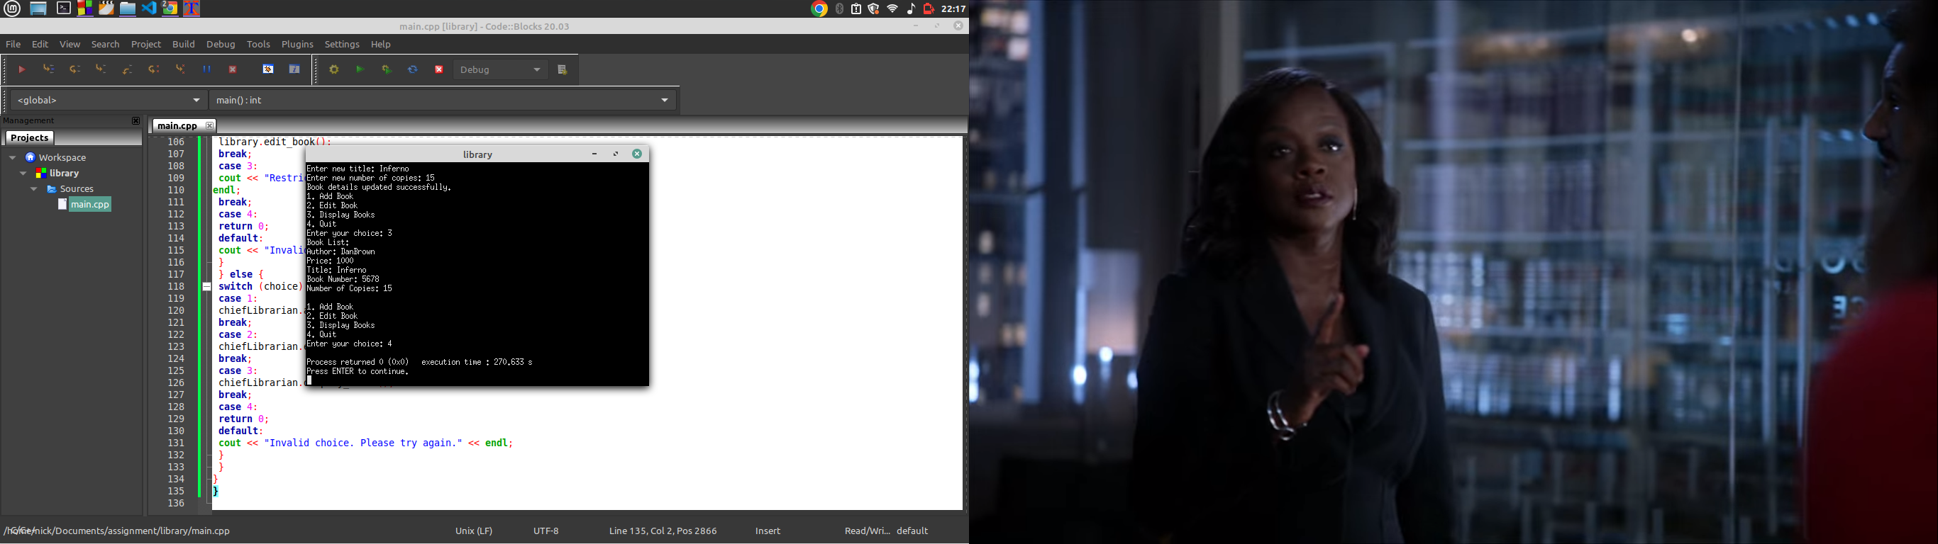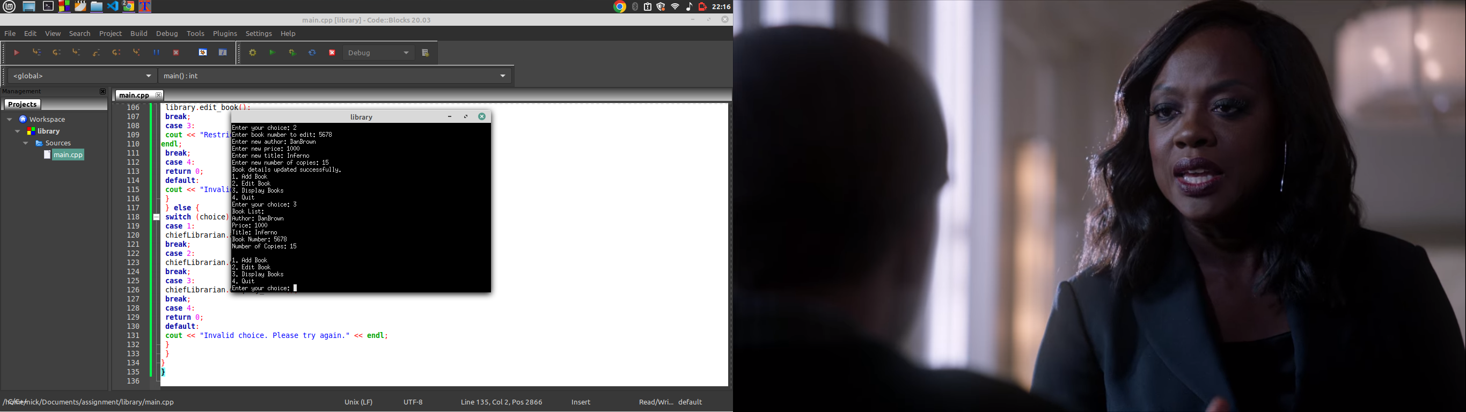

**No.2**

**INPUT**

#include <iostream>

#include <string>

using namespace std;

class Vehicle{

private:

string make;

string model;

string engine_number;

float sale_price;

public:

void set_vehicle(string m, string mod, string en, float sp){

make = m;

model = mod;

engine_number = en;

sale_price = sp;

}

float get_profit(){

float profit = sale_price * 0.15;

return profit;

}

};

int main(){

Vehicle v1;

string make, model, engine_number;

float sale_price;

cout<<"Enter the make of the vehicle:";

cin>>make;

cout<<"Enter the model of the vehicle:";

cin>>model;

cout<<"Enter the engine_number of the vehicle:";

cin>>engine_number;

cout<<"Enter the sale price of the vehicle:";

cin>>sale_price;

v1.set_vehicle(make, model, engine_number,sale_price);

cout<<"Profit earned is:"<<v1.get_profit()<<endl;

return 0;

}

**Outputs**

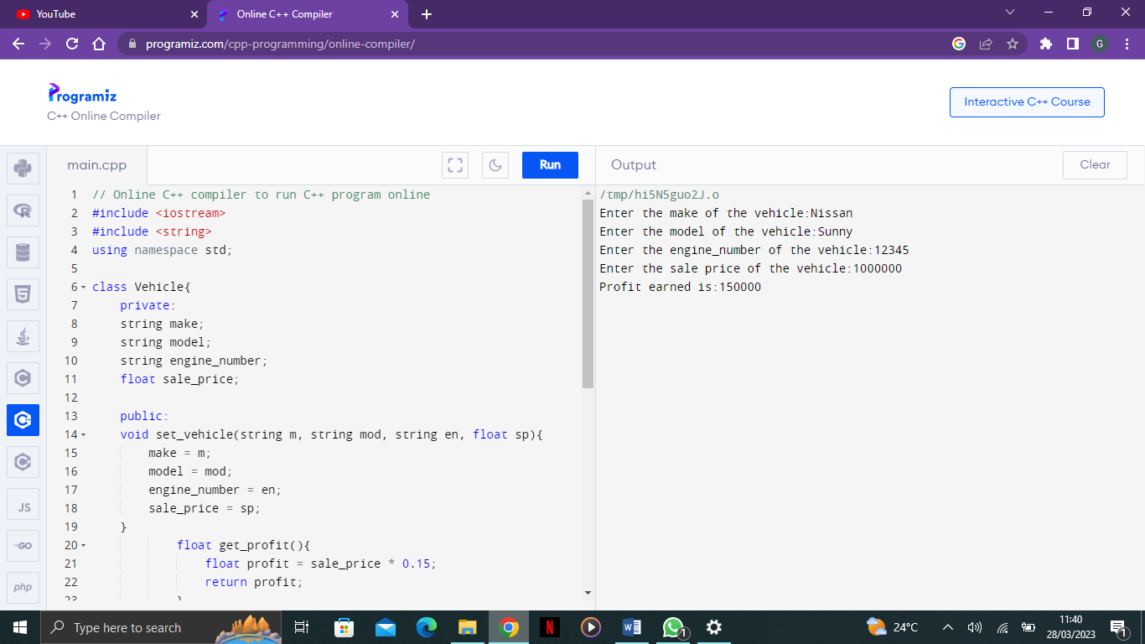

**No.3**

**INPUT**

#include <iostream>

#include <string>

#include <vector>

using namespace std;

class Voter{

private:

string voter_card_id;

string national_id_number;

string first_name;

string middle_name;

string surname;

string polling_station;

string date_of_birth;

string gender;

public:

// Constructor to initialize all member variables

Voter() : voter_card_id(""), national_id_number(""), first_name(""), middle_name(""), surname(""), polling_station(""), date_of_birth(""), gender("") {}

// Destructor to clean up memory if needed

~Voter() {}

// Function to set all member variables to their default values

void reset_voter() {

voter_card_id = "";

national_id_number = "";

first_name = "";

middle_name = "";

surname = "";

polling_station = "";

date_of_birth = "";

gender = "";

}

// Function to add a new voter

void add_voter(){

reset_voter(); // reset all member variables to default values before adding a new voter

cout<<"Enter your voter card ID: ";

cin>>voter_card_id;

cout<<"Enter your national ID: ";

cin>>national_id_number;

cout<<"Enter your first name: ";

cin>>first_name;

cout<<"Enter your middle name: ";

cin>>middle_name;

cout<<"Enter your surname: ";

cin>>surname;

cout<<"Enter polling station: ";

cin>>polling_station;

cout<<"Enter date of birth (in dd-mm-yyyy format): ";

cin>>date_of_birth;

cout<<"Enter your gender: ";

cin>>gender;

}

// Function to display voter details

void display_voter(){

cout<<"Voter card ID: "<<voter_card_id<<endl;

cout<<"National ID number: "<<national_id_number<<endl;

cout<<"Name: "<<first_name<<" "<<middle_name<<" "<<surname<<endl;

cout<<"Date of birth: "<<date_of_birth<<endl;

cout<<"Gender: "<<gender<<endl;

}

};

int main(){

vector<Voter> voters; // create a vector to store all voters

string command; // create a variable to store user commands

// loop to input voters until user chooses to stop

while (true) {

Voter v;

v.add_voter();

voters.push_back(v); // add the new voter to the vector

v.display_voter();

// ask user if they want to continue or stop

cout << "Enter 'exit' to stop adding voters, or any other key to continue: ";

cin >> command;

if (command == "exit") {

break; // exit the loop if user types "exit"

}

}

}

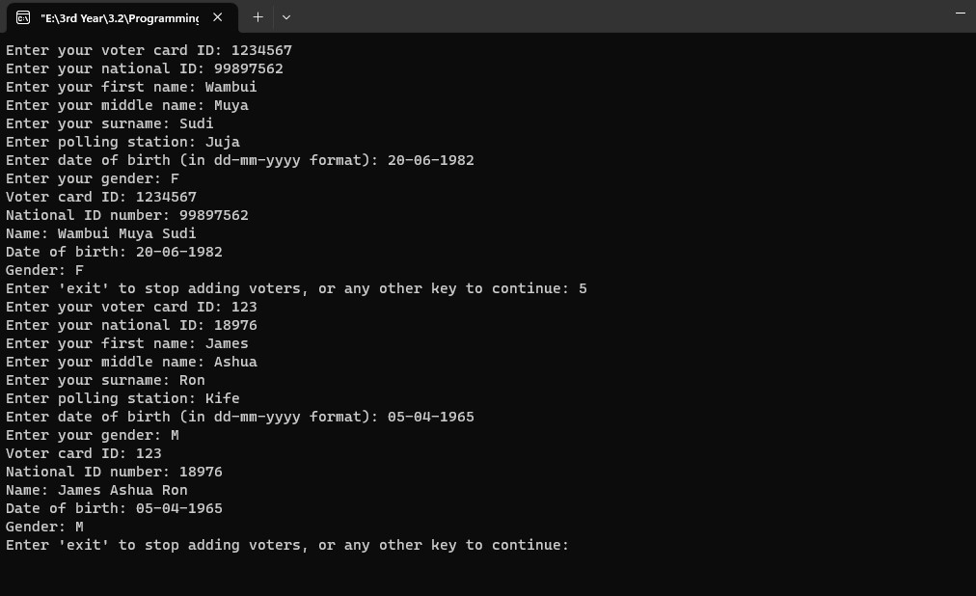**OUTPUT**

**No.4**

**INPUT**

#include<iostream>

#include <string>

using namespace std;

class Subscriber {

private:

string name;

string phone_number;

double airtime_amount;

int bonus_points;

public:

Subscriber(string n, string p, double a){

name=n;

phone_number=p;

airtime_amount=a;

bonus_points=compute_bonuspoints();

}

int

compute_bonuspoints(){

if(airtime_amount>=2000.00)

{

return 500.00;

}

else if(airtime_amount>=1000.00 && airtime_amount<2000.00)

{

return 300;

}

else if(airtime_amount>=500.00 && airtime_amount< 1000.00)

{

return 100;

}

else if(airtime_amount>=100.00 && airtime_amount< 500.00)

{

return 50;

}

else {

return 0;

}

}

void display_info(){

cout<<name<<":(PHONE NO:"<<phone_number<<"):AWARDED "<<bonus_points<<" BONGA POINTS. STAY WITH SAFARICOM. THE BETTER OPTION!"<<endl;

}

};

int main(){

string name,

phone_number;

double airtime_amount;

cout<<"Enter Subscriber name:";

getline(cin, name);

cout<<"Enter Phone number:";

getline(cin, phone_number);

cout<<"Enter Airtime amount:";

cin>>airtime_amount;

Subscriber

subscriber(name, phone_number,airtime_amount);

subscriber.display_info();

return 0;

}

**OUTPUT**

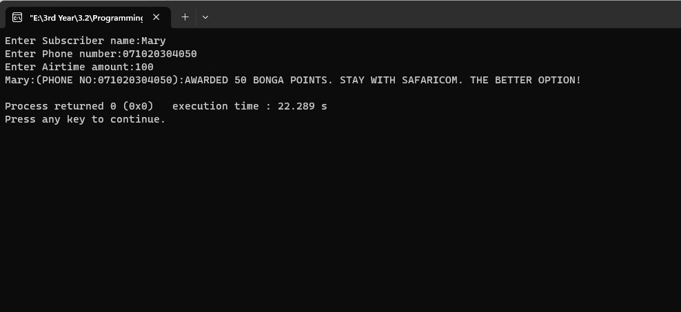

**No.5**

**INPUT**

#include <iostream>

#include <string>

using namespace std;

class employee {

private:

int employee_id;

string first_name;

string second_name;

string surname;

string gender;

string dob;

float monthly_salary;

public:

employee(int id, string fname, string sname, string surn, string g, string birthdate, float salary)

: employee_id(id), first_name(fname), second_name(sname), surname(surn), gender(g), dob(birthdate), monthly_salary(salary) {}

void show_employee() {

cout << "Employee ID: " << employee_id << endl;

cout << "Name: " << first_name << " " << second_name << " " << surname << endl;

cout << "Gender: " << gender << endl;

cout << "Date of Birth: " << dob << endl;

cout << "Monthly Basic Salary: $" << monthly_salary << endl;

}

friend float compute_pension(const employee& emp);

};

float compute_pension(const employee& emp) {

float pension_contribution = 0.05 * emp.monthly_salary;

cout << "Pension Contribution: $" << pension_contribution << endl;

return pension_contribution;

}

int main() {

// Prompts the user to enter employee details

int employee_id;

string first_name, second_name, surname, dob_str;

string gender;

float monthly_salary;

cout << "Enter Employee ID: ";

cin >> employee_id;

cout << "Enter First Name: ";

cin >> first_name;

cout << "Enter Second Name: ";

cin >> second_name;

cout << "Enter Surname: ";

cin >> surname;

cout << "Enter Gender (Male/Female): ";

cin >> gender;

cout << "Enter Date of Birth (dd-mm-yyyy): ";

cin >> dob_str;

cout << "Enter Monthly Basic Salary: $";

cin >> monthly_salary;

// Create an employee object

cout << endl<<" THE EMPLOYEE DETAILS ARE: "<< endl<<endl;

employee emp_obj(employee_id, first_name, second_name, surname, gender, dob_str, monthly_salary);

// Display employee information

emp_obj.show_employee();

// Compute pension contribution

compute_pension(emp_obj);

return 0;

}

**OUTPUT**

